Below is the link for GITHUB code.

**https://github.com/laxmikantbpandhare/cmpe202/tree/master/lab1/gumball-java-typical**

I ran it on Console.

Gumball Machine One 🡪

If user enters 25 Cents then Gumball Gets ejected for Gumball Machine One.

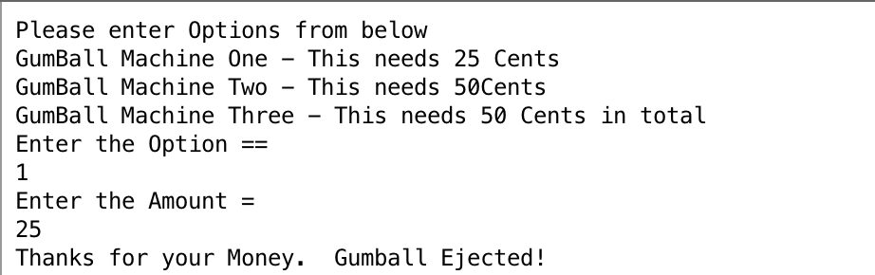

Now, for gumball Machine One if I enter money less than 25.

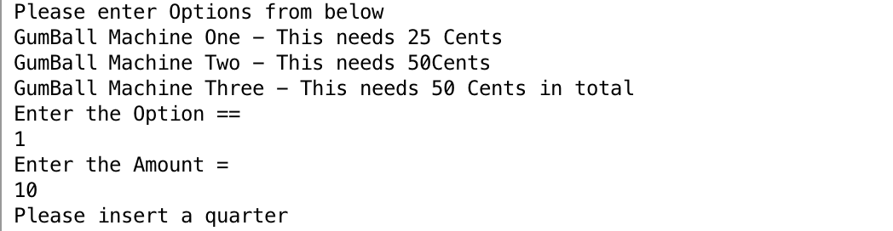

I have utilized same function for Gumball Machine Two and Gumball Machine Three.

So, the code used with no other maintenance.

The two same methods used are.

Now, Gumball Machine Two

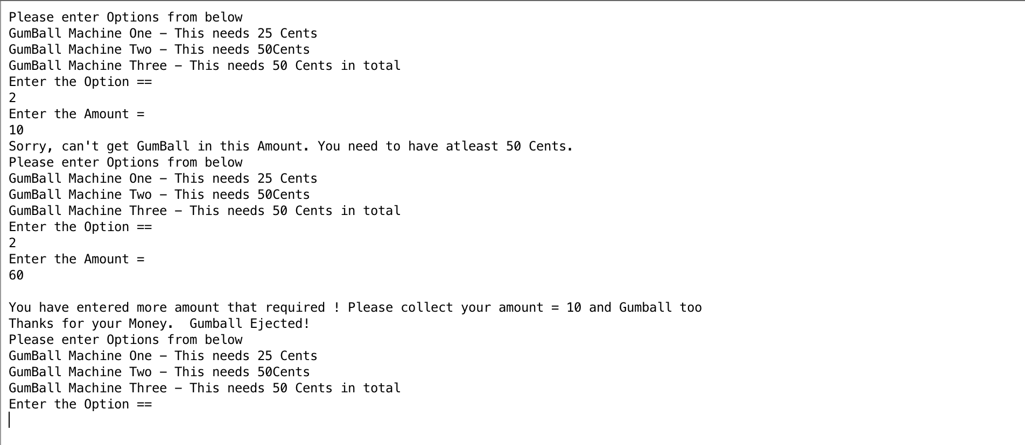

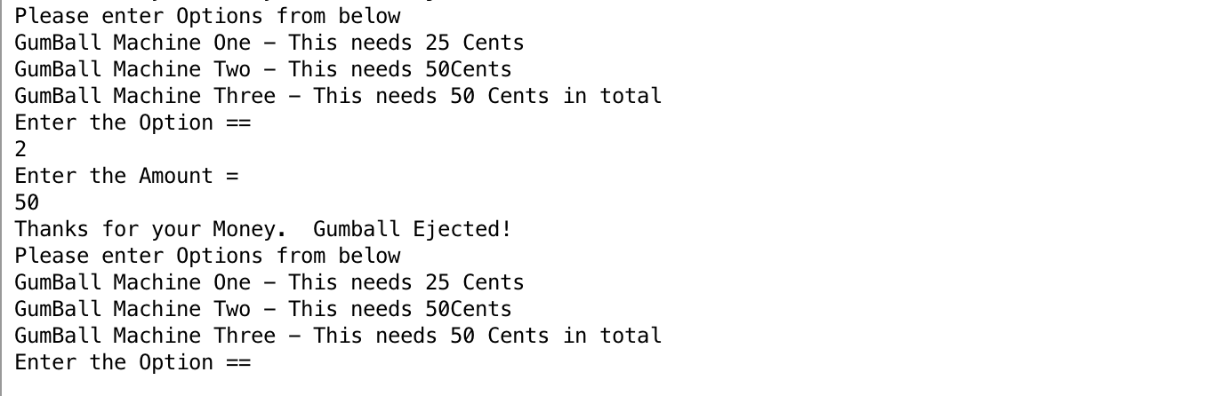

Gumball Machine Three,

